Task 1: Your First Script
- Create a file hello.sh
- Add the shebang line #!/bin/bash at the top
- Print Hello, DevOps! using echo
- Make it executable and run it
chmod +x hello.sh
./hello.sh
Document: What happens if you remove the shebang line? – It worked without giving any issue as it is a comment
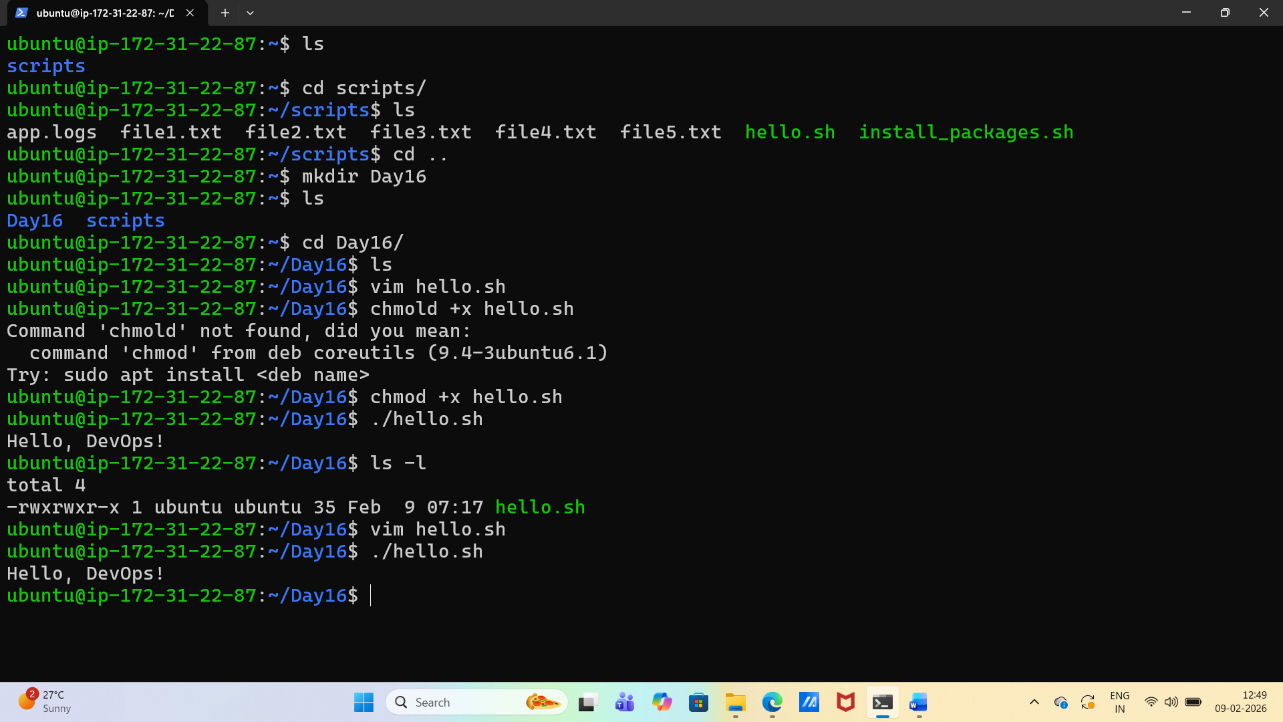
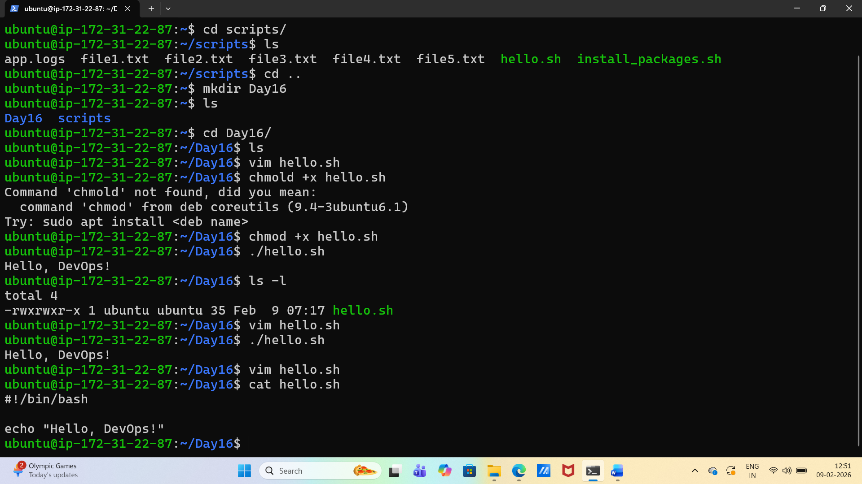

Task 2: Variables
- Create variables.sh with:
  - A variable for your NAME
  - A variable for your ROLE (e.g., "DevOps Engineer")
  - Print: Hello, I am <NAME> and I am a <ROLE>
- Try using single quotes vs double quotes — what's the difference?
Worked with variable declaration. Did not work with echo statement.
It worked when ‘Hello, I am ‘$NAME ‘and I am a ‘$ROLE

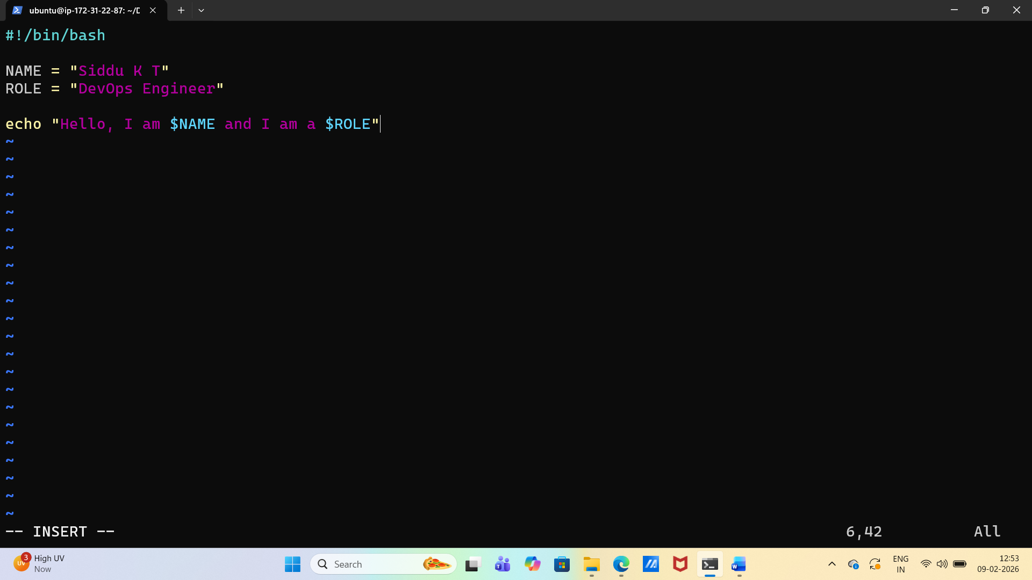
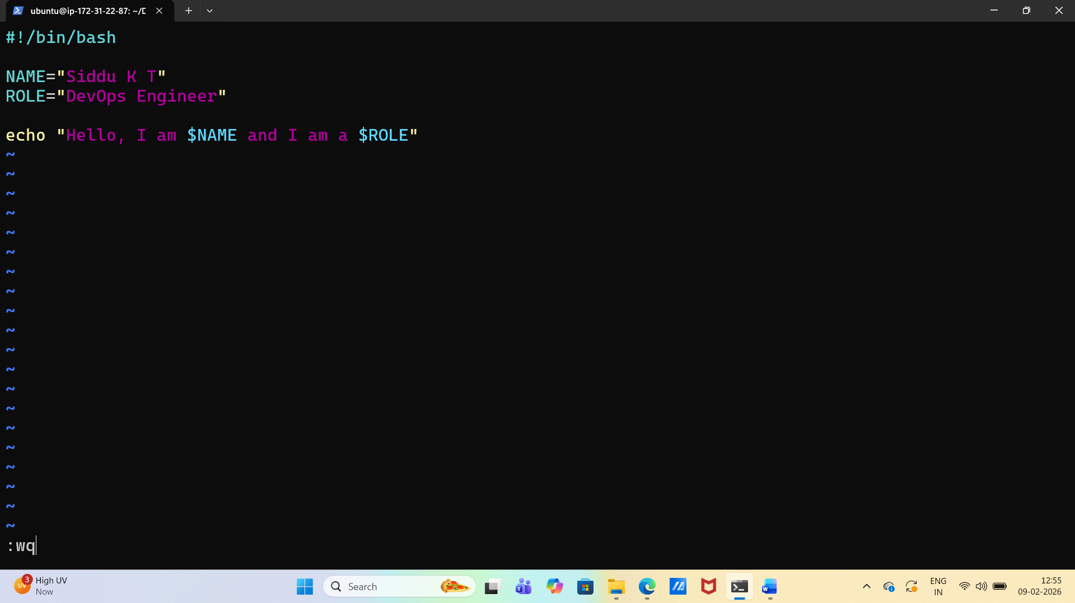
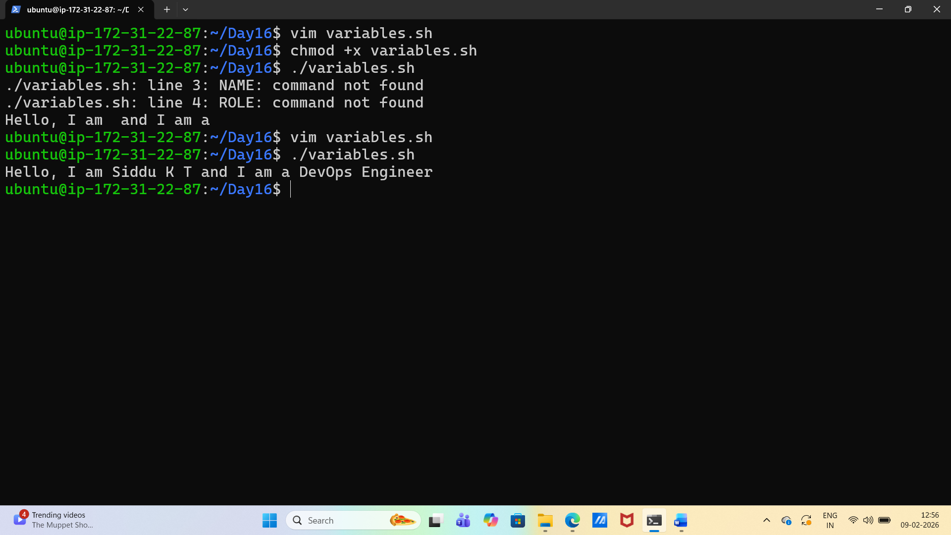

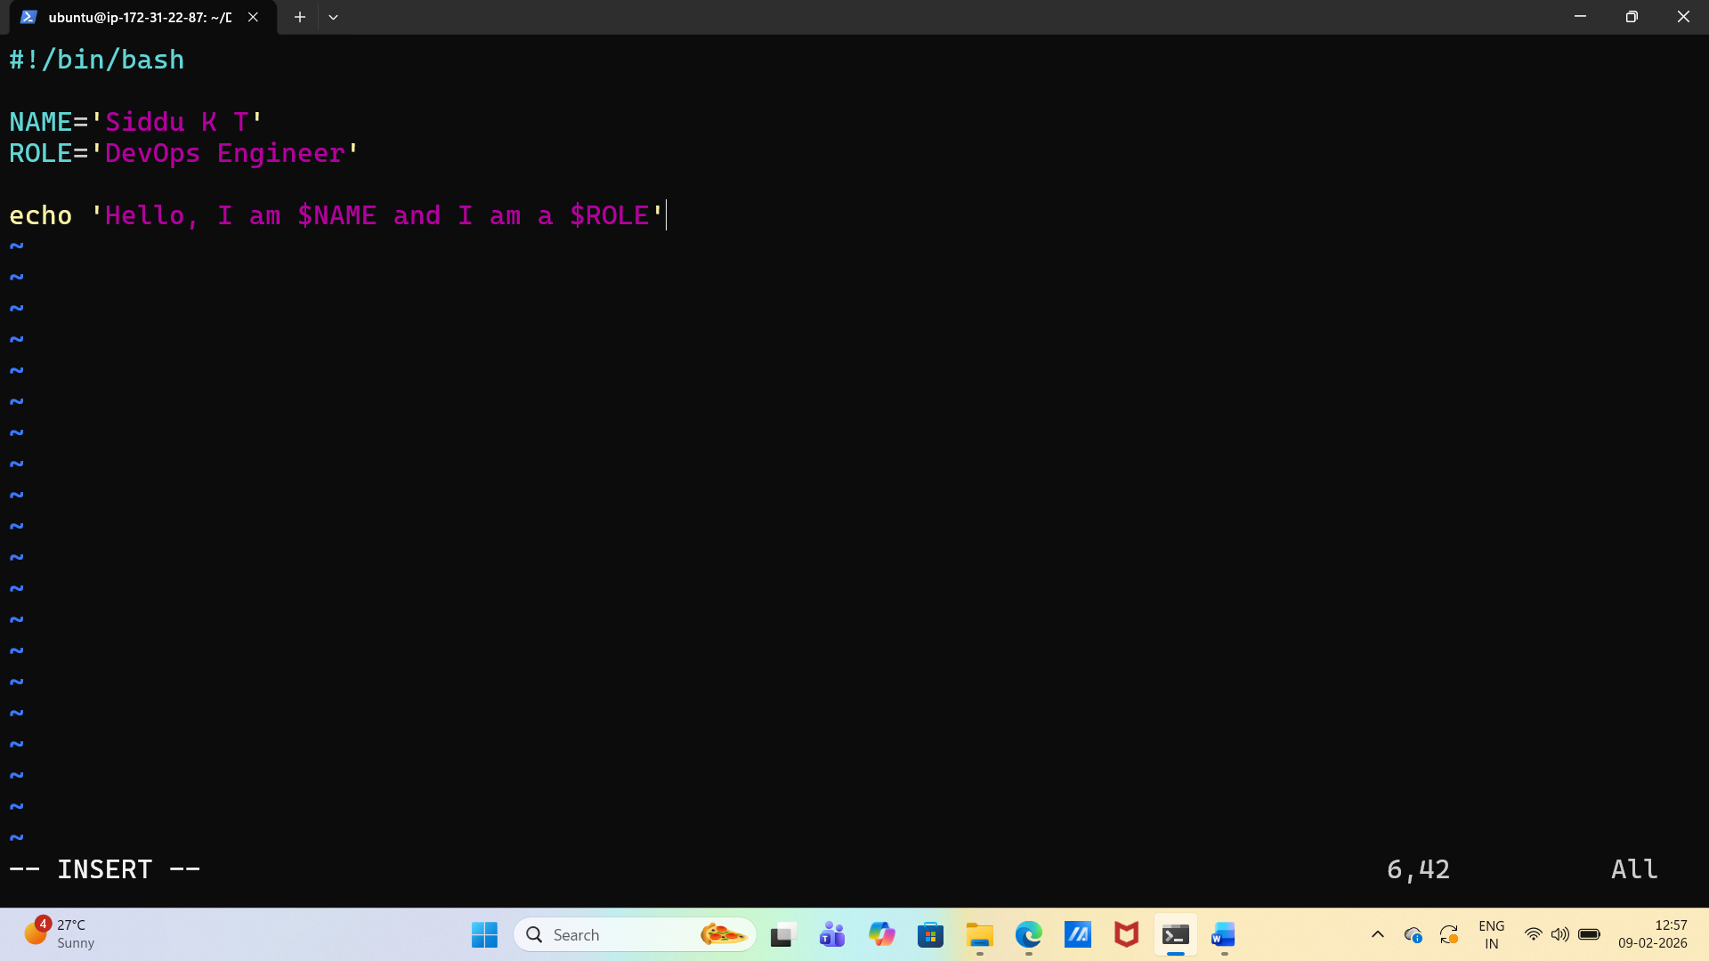
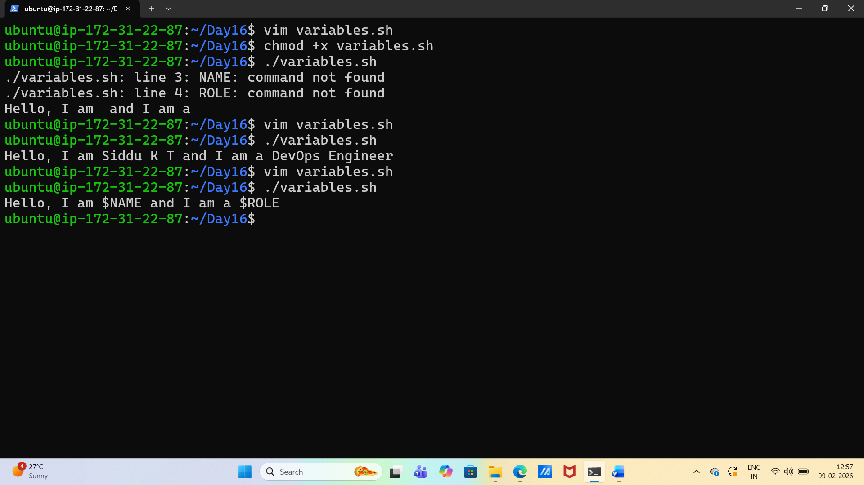

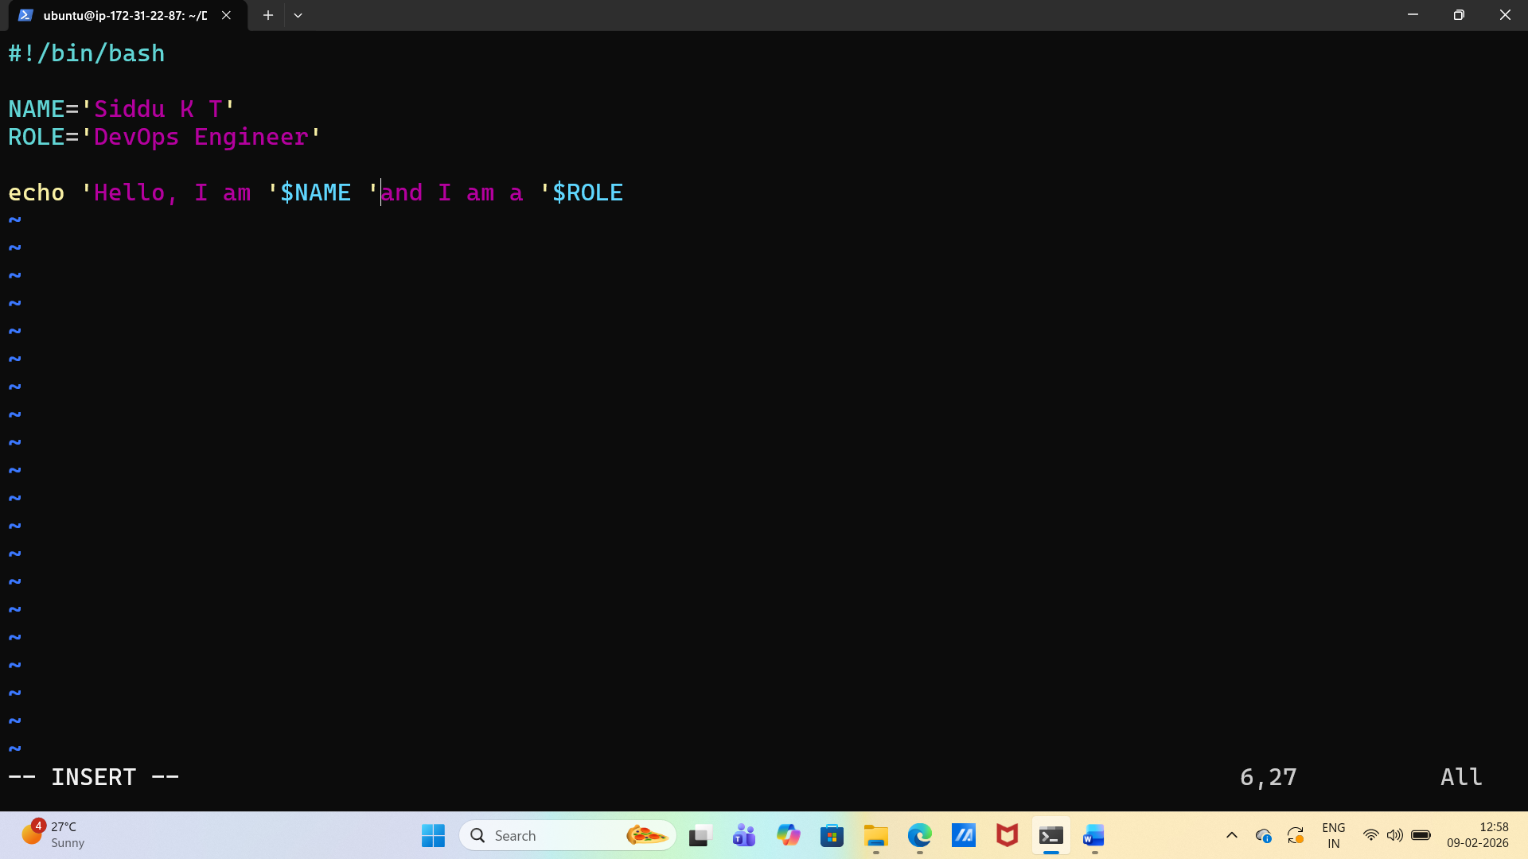
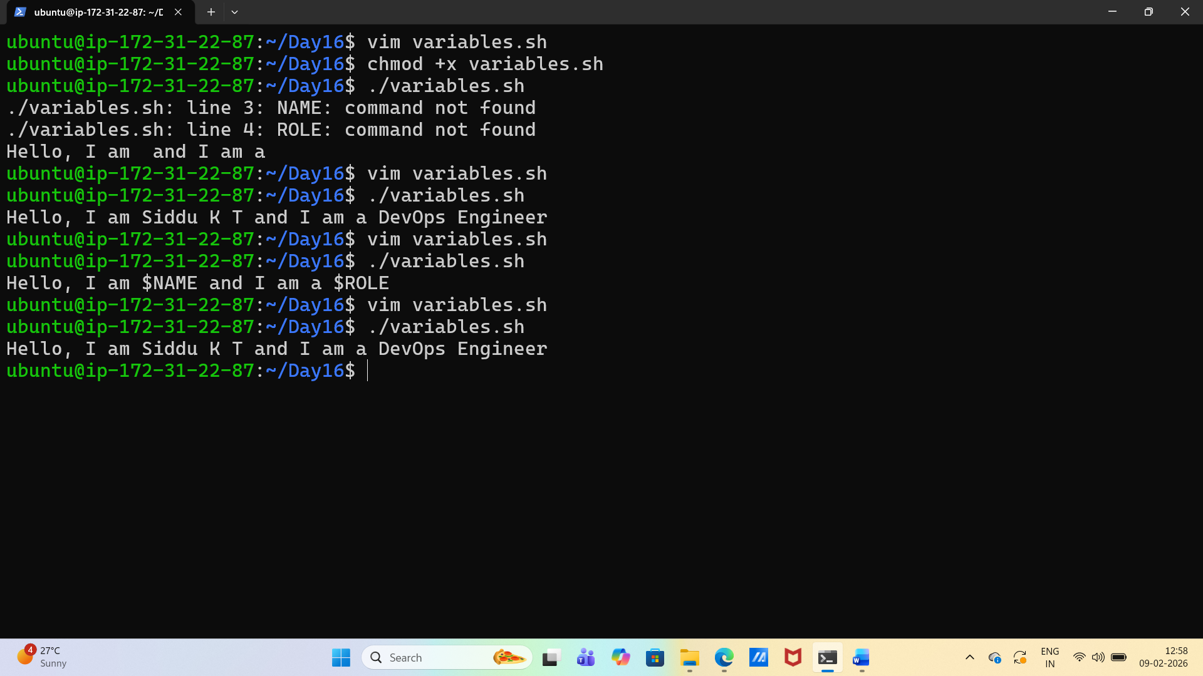

Task 3: User Input with read
- Create greet.sh that:
  - Asks the user for their name using read
  - Asks for their favourite tool
  - Prints: Hello <name>, your favourite tool is <tool>

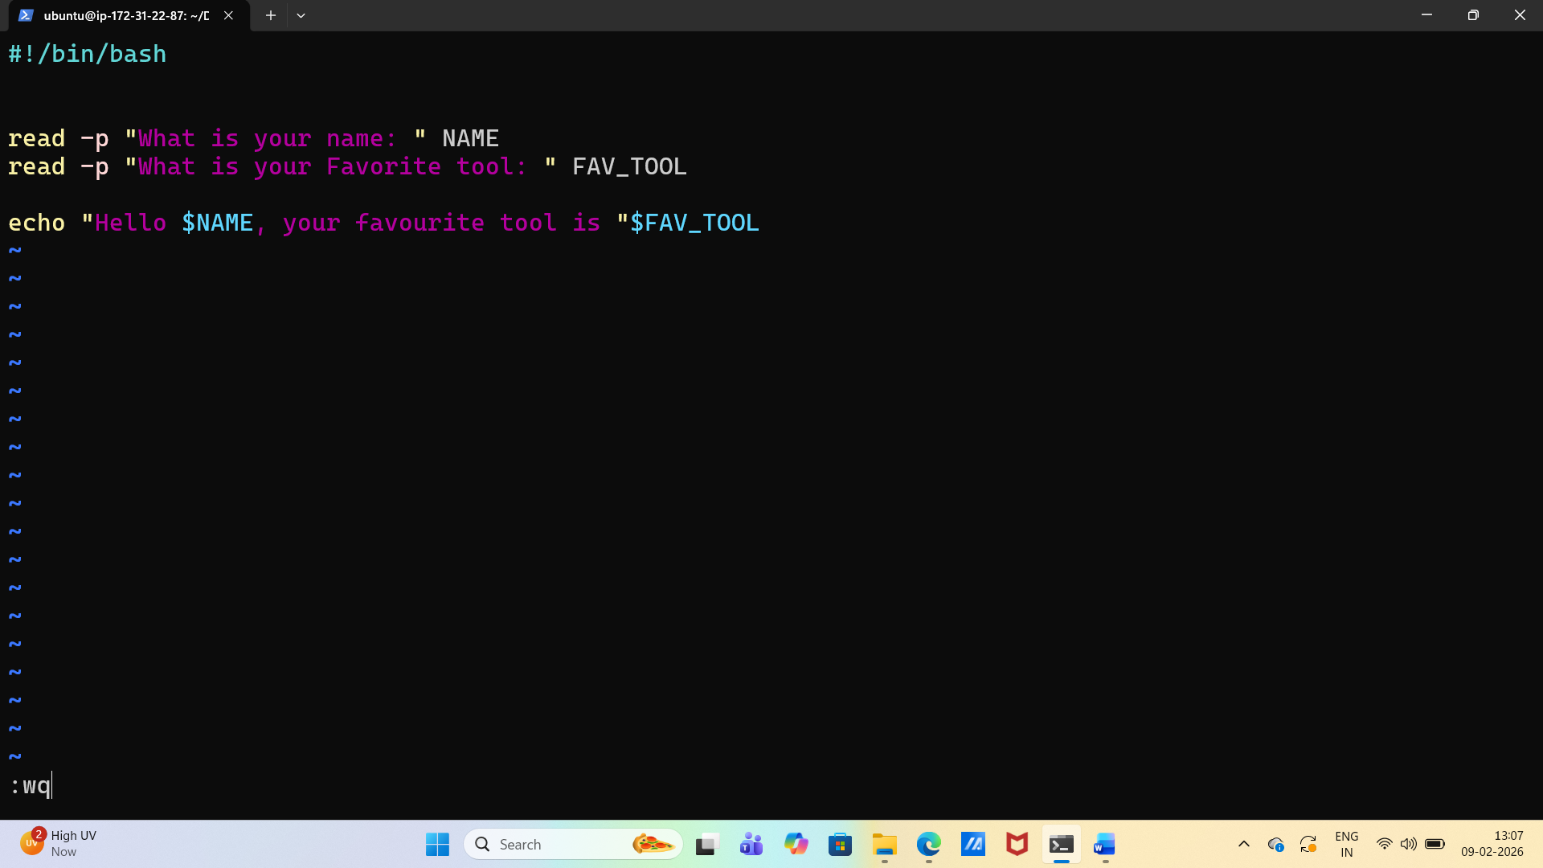

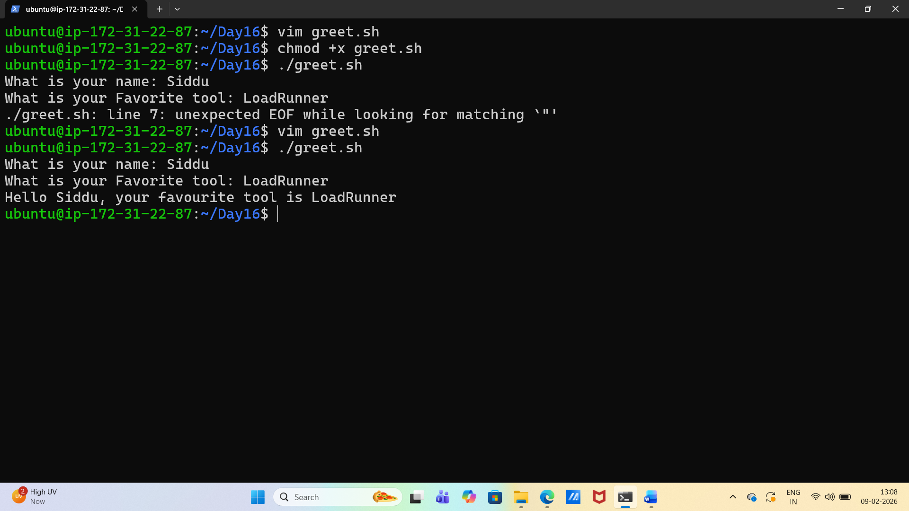
Task 4: If-Else Conditions
- Create check_number.sh that:
  - Takes a number using read
  - Prints whether it is positive, negative, or zero
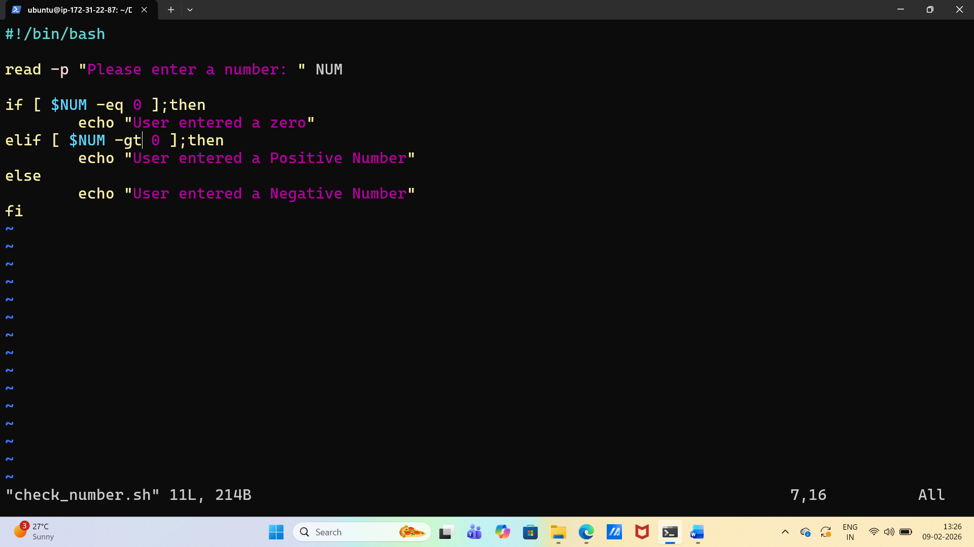
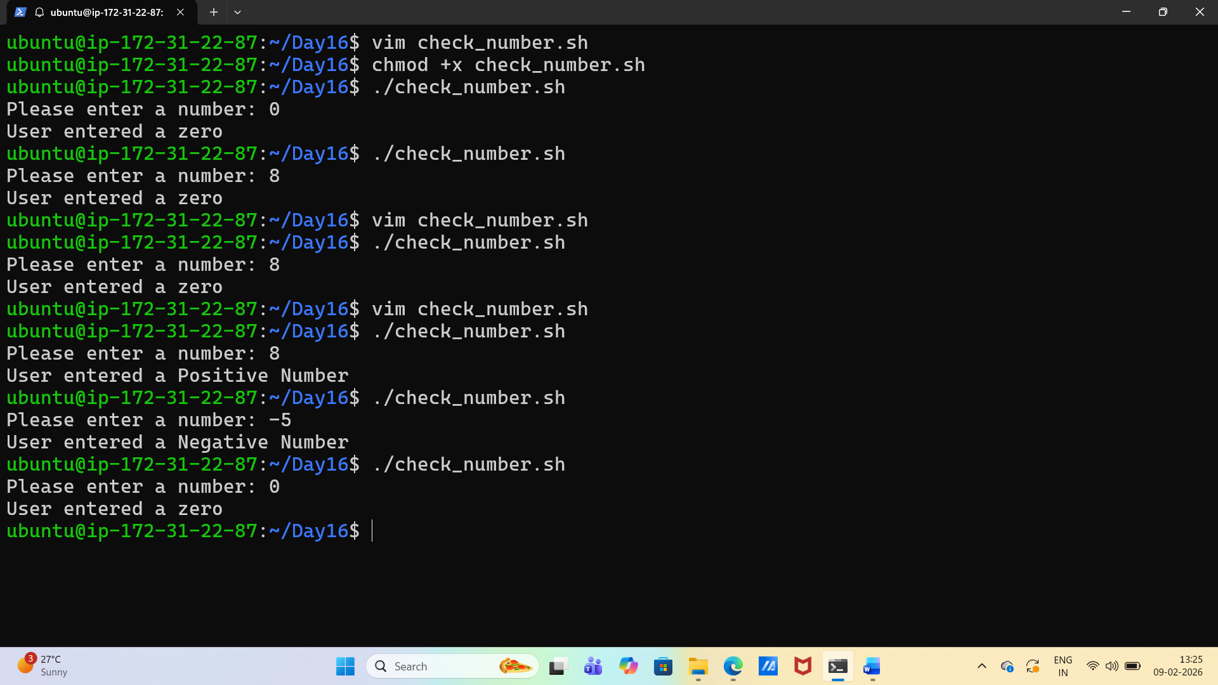

- Create file_check.sh that:
  - Asks for a filename
  - Checks if the file exists using -f
  - Prints appropriate message
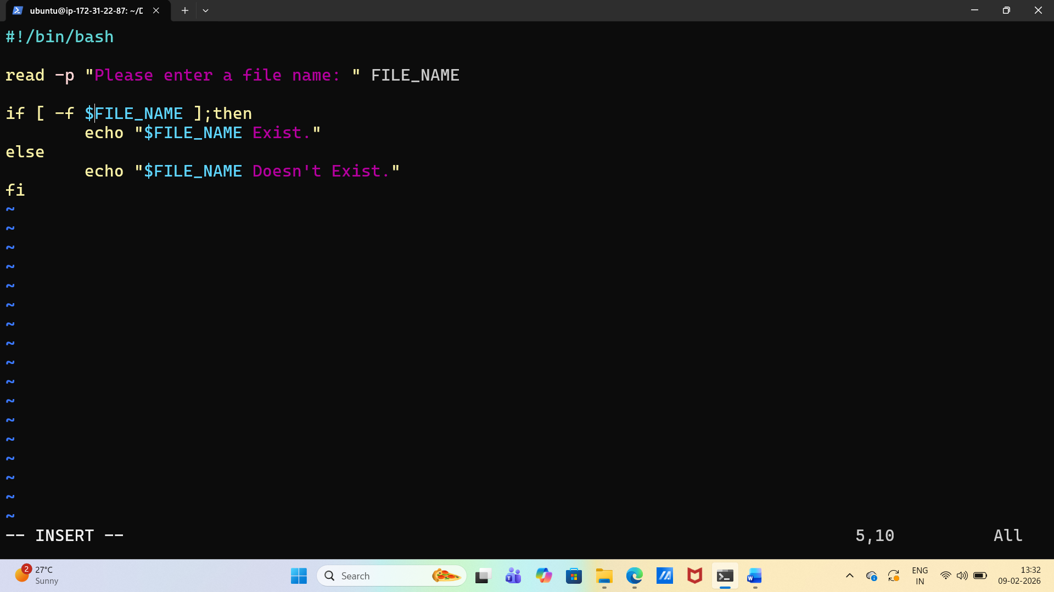
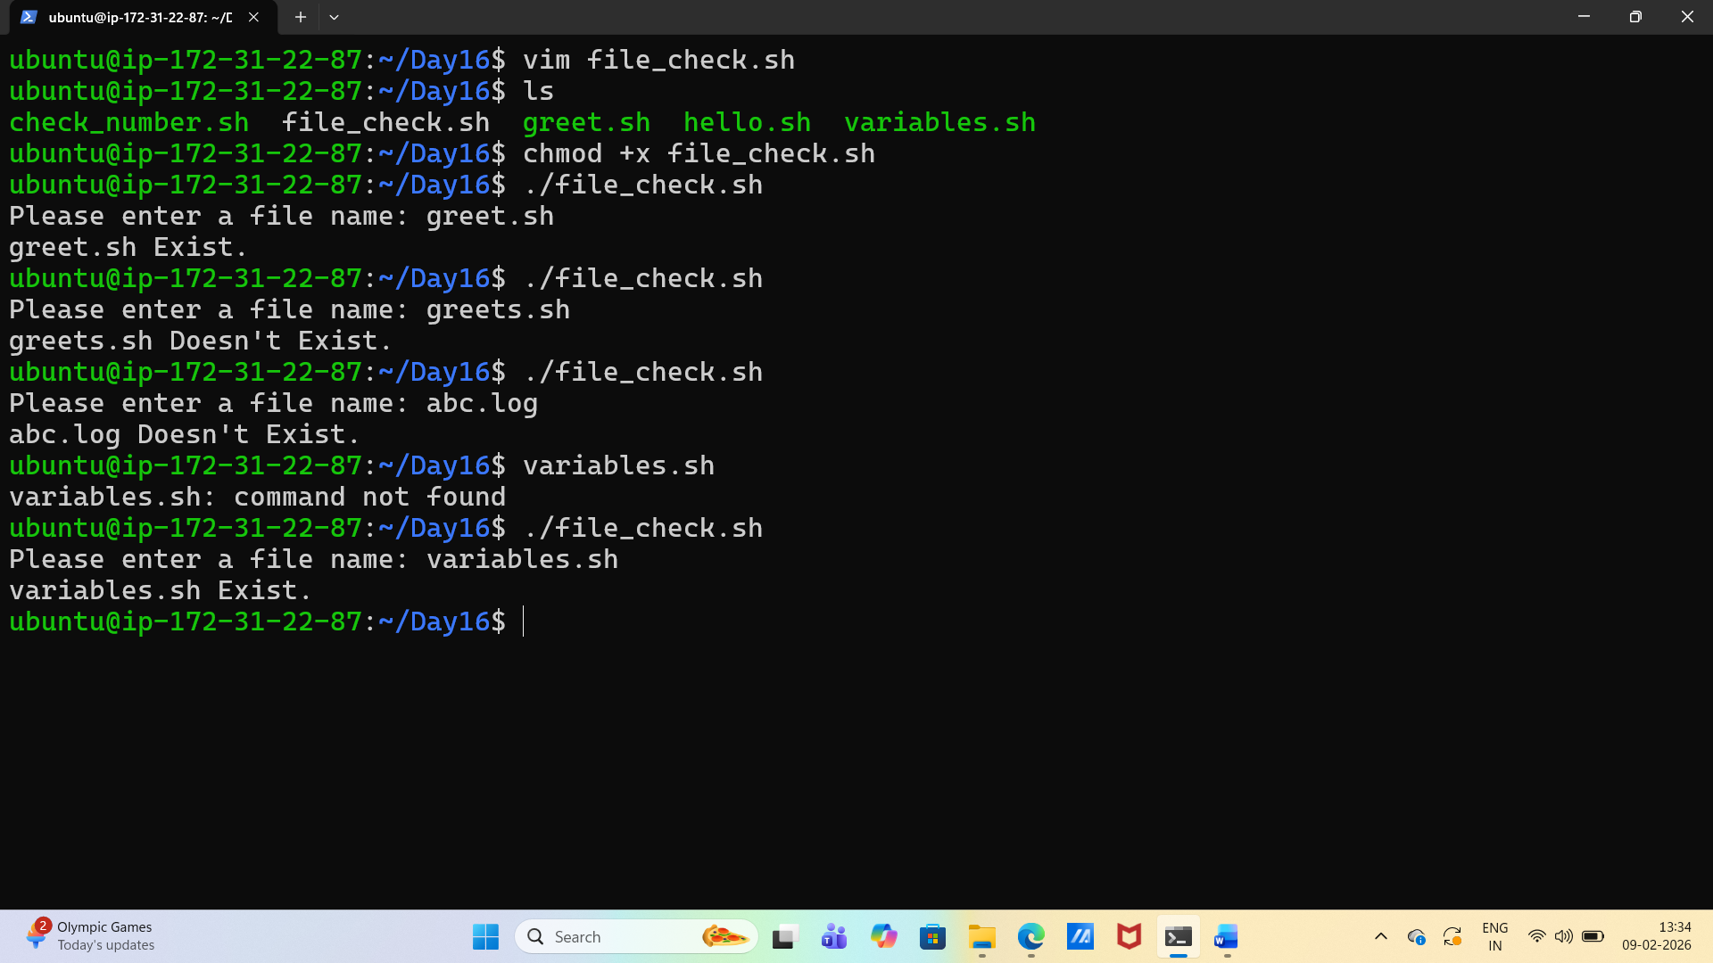

Task 5: Combine It All
Create server_check.sh that:
- Stores a service name in a variable (e.g., nginx, sshd)
- Asks the user: "Do you want to check the status? (y/n)"
- If y — runs systemctl status <service> and prints whether it's active or not
- If n — prints "Skipped."

